**Technological and economic feasibility of de-centralised photo-voltaic systems**

Niels Clayton

**Abstract:**

**Introduction:**

This report will be assessing the technological and economic feasibility of de-centralised photo-voltaic micro-grids in the rural locations of Cameroon, Haiti, India, Kenya, Nigeria, South Sudan, and Zambia. These countries are current members of the ‘IEEE smart village’ program, a program which helps to implement and maintain these types of off grid systems, giving affordable access to renewable electricity in locations where before there was none. This report will be assessing their feasibility as an option in the progression of the sustainable development goal 7 (SDG-7) as set by the United Nations. The goal is to substantially increase the total percentage of renewable energy within the global consumption, double the rate of improvement in energy efficiency, and provide affordable and clean energy to everyone worldwide, all by the year 2030. This access to clean energy will be essential in achieving many of the other sustainable development goals. Giving rural locations reliable access to energy will allow for them to develop and expand their state of living. Access to electricity will allow for an increase in agriculturally viable land, the pumping of clean water, and allow for access to necessities such as lighting, heating, and safe cooking methods.

Because of the importance of the availability of clean affordable energy, this report will be looking at the ways it can be provided, and if off-grid photo-voltaic systems are a feasible solution to this issue. This report will be looking into the countries in which these systems are currently being implemented, looking at their climates and how they will affect the need for electricity throughout the week / year, as well as current governmental programs that may either help of hinder. This will then be used to create a model of a photovoltaic grid in the given environment, which will be used to evaluate the feasibility of the system in achieving the goals of the sustainability development goals.

**Literature analysis:**

The purpose of this review is to gain an understanding of the difference of load profiles between seasonal changes within the countries looked at by the IEEE smart village program. It will identify the differences of electrical usage between differing countries due to differences in climate, geographical location, and governmental interventions. This review will focus on the different load profiles of households within these countries.

Key search words:

Different variations of these key words and their synonyms were used to retrieve the greatest array of useful articles to the subject question. Using this table of applicable search terms, searches combining each of the key words or their synonyms will be done, (i.e. “India” AND “IEEE” OR “rural” AND “Photovoltaic” OR “Seasonal” AND “Appliance usage”). The resulting articles will be analysed. All the information pertaining to the posed question will be assessed to create a load profile. This load profile will then be used to assess weather de-centralised photovoltaic grids are feasible within the given circumstances.

|  |  |  |  |  |  |  |  |
| --- | --- | --- | --- | --- | --- | --- | --- |
| **Key Word** | **Group 1** | **Group 2** | **Group 3** | **Group 4** | **Group 5** | **Group 6** | **Group 7** |
| ‘Country’ | Cameroon | Haiti | India | Kenya | Nigeria | South Sudan | Zambia |
| IEEE | - | - | - | - | - | - | - |
| Rural | Village | Off Grid | - | - | - | - | - |
| Photovoltaic | Solar Panel | Photovoltaic grid | - | - | - | - | - |
| Seasonal | Summer | Winter | Monsoon | - | - | - | - |
| Load Profile | Daily usage | Weekly load | Monthly load | Yearly load | - | - | - |
| Renewable | Solar energy | - | - | - | - | - | - |
| Appliance usage | Appliance in rural locations | Appliances | Power usages | - | - | - | - |

Already available load profiles:

India:

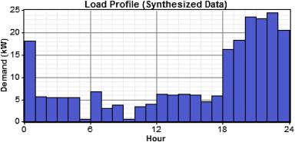

This load profile was taken from the international journal of green energy, (P. Balamurugan , S. Ashok & T. L Jose, 2009). We are intending to look only at the profile of the primary load, as the system we intend to investigate only has photovoltaic panels available for electrical generation.

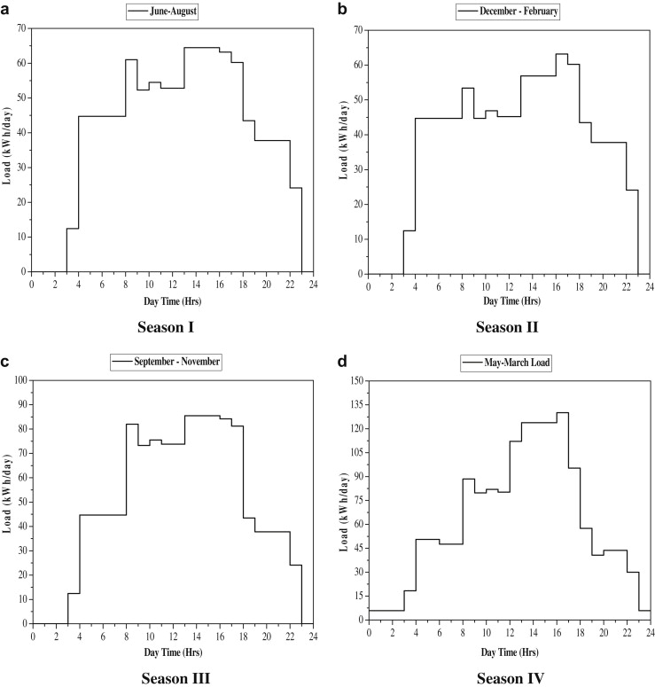

Seasonal load profiles from within India, taken from ScienceDirect’s publication of “Renewable Energy” (A.B. Kanase-Patil, 2011). From these profiles we can ascertain that in India the greatest demand for electricity is during the monsoon season. During this period temperatures are high, along with humidity. This combination leads to an increase in power usage in the form of cooling and ventilation. It can also be seen that most of the power usage doesn’t begin till near the hours of 6-8. During this time, it can be assumed that people are preparing for the day. After this, the load spikes as industrial work begins, and energy is used for agriculture, and construction. Because of this the load remains static until near 6pm, when it drops again as the only load will be that from households in the form of TV or lighting.

Kenya:

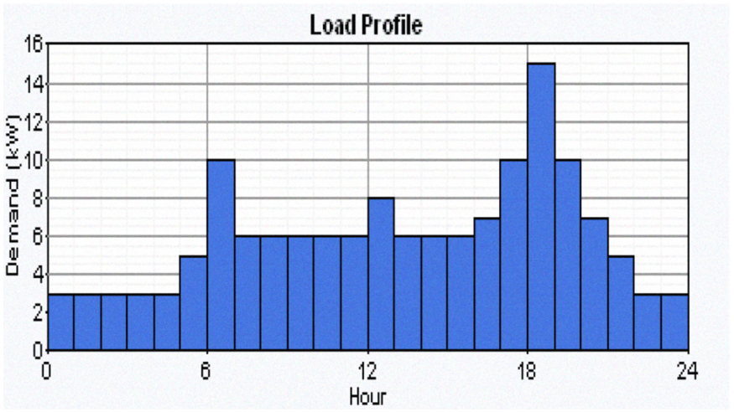

This load profile taken from “Feasibility study of a hybrid PV-Micro Hydro system for rural electrification” (K. Kusakana, 2009) if a combination of two different load profiles generated for a rural village in Kenya. The household daily load curve presents a peak in the morning, then one during lunch hours, and most substantially, one in the evening hours from 6.00 pm, till around 10.00 pm. The constant load shown to be present between the hours of 6 pm- 6am is due to the security lighting of facilities, and the near constant load between 7am -5pm dues to the running of machinery.

**Table 2. Loads of entity with no seasonal variation**

|  |  |  |  |  |  |
| --- | --- | --- | --- | --- | --- |
| **Electrical appliances** | **Number used** | **Wattage** | **Total Wattage** | **Daily Duty Cycle** | **Daily Energy Consumed kWh/day** |
| Water Pump | 1 | 250 | 250 | 1 | 0.250 |
| Radio | 1 | 15 | 30 | 2 | 0.060 |
| **Constant Load Total** |  |  | **1356** |  | **0.310** |

**Table 3. Daily loads subject to seasonal variation**

|  |  |  |  |  |  |  |
| --- | --- | --- | --- | --- | --- | --- |
| **Season** | **Electrical appliances** | **Number used** | **Wattage** | **Total Wattage** | **Daily Duty Cycle** | **Daily Energy Consumed kWh/day** |
| Summer | Ceiling fan | 2 | 30 | 60 | 15 | 0.900 |
|  | Lights (LED Bulbs) | 4 | 20 | 80 | 5 | 0.400 |
| **Load Total** |  |  |  | **60** |  | **1.300** |
|  |  |  |  |  |  |  |
| Winter | Ceiling fan | 2 | 30 | 60 | 0 | 0 |
|  | Lights (LED Bulbs) | 4 | 20 | 80 | 9 | 0.720 |
| **Load Total** |  |  |  | **60** |  | **0.720** |
|  |  |  |  |  |  |  |
| Monsoon | Ceiling fan | 2 | 30 | 60 | 0 | 0 |
|  | Lights (LED Bulbs) | 4 | 20 | 80 | 7 | 0.560 |
| **Load Total** |  |  |  | **60** |  | **0.560** |

Winter

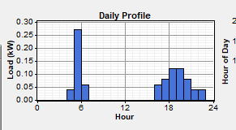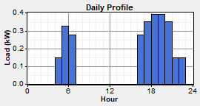

Summer

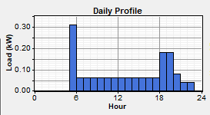

Monsoon

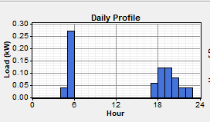

Global Horizontal Radiation

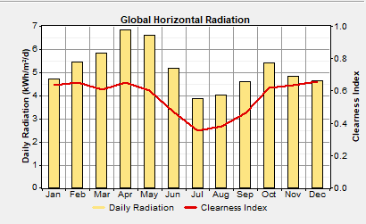

Wind resource

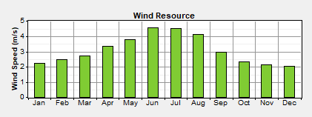

These two load profiles (Summer/Winter) have been created using a combination the previously shown profiles, but on a much smaller scale. All of the before mentioned profiles were done on houses in areas of greater economical development and therefor had access to a larger array of products than a small rural village would have. Using the information from “Sizing of integrated renewable energy systems” (Kanase-Patil, 2011) I have been able to estimate the average appliance usage of a household in a small rural village. Firstly, I have assumed that the household will most likely consist of no more than 3 separate room, because of this only a small amount of lighting is required within the household. One light per room should be enough, so I have allocated for 4 lightbulbs in case some extra lighting is required. The lighting type I have implemented is LED bulbs, this is because of their efficiency when compared to a regular incandescent or tube bulb. I have also chosen to use LED’s since their pricing has recently decreased due to India’s initiative to “make Indian energy efficient” (Yang. M – 2005). I have also chosen that in summer there will not be any need for heating, however there will be an increase in the usage of ceiling fans (one in each room). These ceiling fans are set to be running all of the time that the household is occupied (from 6.00 pm – 8.00 am), and then they will be switched off to conserve energy. In winter however, heating will be required, but only for a short period in the mornings, and then in the evening before the occupants go to sleep. This will total to around 8 hours of total usage a day.

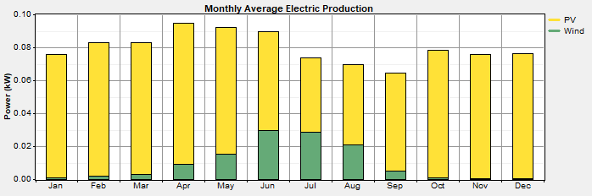

**Homer report:**

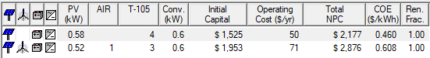

**RETScreen report:**

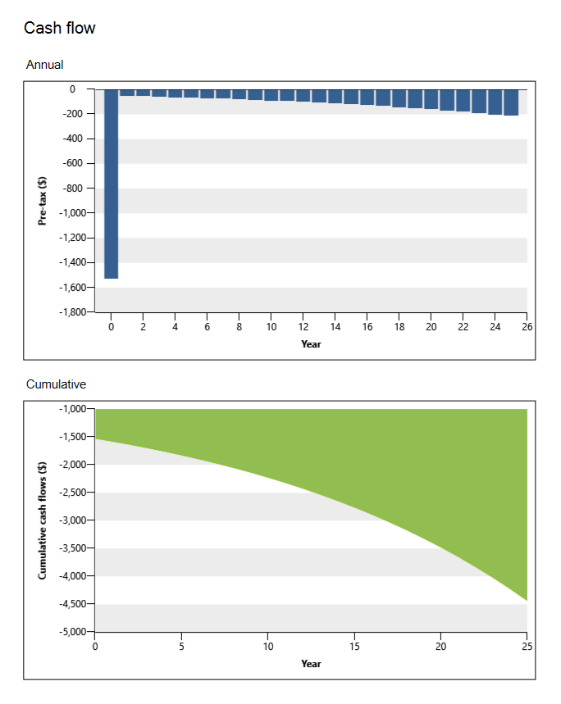

When comparing the reports output by both Homer and RETScreen there are a lot of differences. The first of these will stem from the fact Homer, unlike RETScreen, allowed the user to input their own load profile for the given load, giving it a more accurate representation of the actual load of the given household. Homer also would not allow you to perform the analysis if there wasn’t certainty that the loads of the house would be met. This meant that in homer the implementation of both a battery for the storage of energy, and a generator for when the photovoltaic panels could not supply were mandatory. This is a large upside as it means that the system generated is a lot more reliable then the one that can be generated by RETScreen.

**References:**

Balamurugan, P., Ashok, S. and Jose, T.L., 2009. Optimal operation of biomass/wind/PV hybrid energy system for rural areas. *International Journal of Green Energy*, *6*(1), pp.104-116.

Kanase-Patil, A.B., Saini, R.P. and Sharma, M.P., 2011. Sizing of integrated renewable energy system based on load profiles and reliability index for the state of Uttarakhand in India. *Renewable Energy*, *36*(11), pp.2809-2821.

A.B. Kanase-Patil, R. S. M. S., 2011. In: *Sizing of integrated renewable energy system based on load profiles and reliability index for the state of Uttarakhand in India.* s.l.:ScienceDirect, pp. 2809-2821.

Alstone. Peter, G. D. K. D. M., 2015. Decentralized energy systems for clean electricity access. *Nature Climate Change,* Volume 5.

Ashok, S., 2007. In: *Optimised model for community-based hybrid energy system, Volume 32, Issue 7.* s.l.:s.n., pp. 1155-1164.

Zomers, A., 2014. Remote access: Context, challenges, and obstacles in rural electrification. *IEEE Power and Energy Magazine*, *12*(4), pp.26-34.

Alstone. Peter, G. D. K. D. M., 2015. Decentralized energy systems for clean electricity access. *Nature Climate Change,* Volume 5.

Khan, N., 2011. Comparative study of energy saving light sources. *Renewable and Sustainable Energy Reviews (ScienceDirect),* 15(1), pp. 296-309.

Alstone, P., Gershenson, D. and Kammen, D.M., 2015. Decentralized energy systems for clean electricity access. *Nature Climate Change*, *5*(4), p.305.

Johnson, N.G. and Bryden, K.M., 2012. Energy supply and use in a rural West African village. *Energy*, *43*(1), pp.283-292.

|  |  |
| --- | --- |
| [1] | S. Ashok, in *Optimised model for community-based hybrid energy system, Volume 32, Issue 7*, 2007, pp. 1155-1164. |
| [2] | N. Khan, “Comparative study of energy saving light sources,” *Renewable and Sustainable Energy Reviews (ScienceDirect),* vol. 15, no. 1, pp. 296-309, 2011. |
| [3] | P. Alstone, D. Gershenson and D. M. Kammen, “Decentralized energy systems for clean electricity access,” *Nature Climate Change,* vol. 5, 2015. |
| [4] | P. Alamurugan, P. Ashok and T. Jose, “Optimal operation of biomass/wind/PV hybrid energy system for rural areas,” *International Journal of Green Energy,* vol. 6, no. 1, pp. 104 -116, 2009. |
| [5] | A. Kanase-Patil, R. Saini and M. Sharma, in *Sizing of integrated renewable energy system based on load profiles and reliability index for the state of Uttarakhand in India*, ScienceDirect, 2011, pp. 2809-2821. |
| [6] | A. Zomers, “Remote access: Context, challenges, and obstacles in rural electrification,” *IEEE Power and Energy Magazine,* vol. 12, no. 4, pp. 22 - 34, 2014. |
| [7] | N. Johnson and K. Bryden, “ Energy supply and use in a rural West African village,” *Energy,* vol. 43, no. 1, pp. 283-292, 2012. |